Tribunal Executive Board Meeting
2/17/2020 at 5:00pm EST
405 ERC
----------------------------------------------------------------------------------------------------------------------------
Attendees: Logan Lindsay, Alex van Haaren, Gus Kohls, Mihir Patel, Thomas Muha, Seth Tumlan, Twisha Anshu, Andrew Naughton, Ore Odubola, Nathan Halbisen, Zachary Higgens, Robbie Schad, Grant Schroeder, Jenna Schniegenberg, Andrew Weideman, Scott Tursic, Emily Schneider

----------------------------------------------------------------------------------------------------------------------------

- Officer & Exec Reports
  - President - Logan Lindsay
    - I had a meeting with NAESC to discuss upcoming conference.
    - National Association of Engineering Student Councils (NAESC) Engineering Summit
      - This is a conference of all the engineering student councils from across the country. The fall semester is the regional one and the spring semester is the national one.
      - Friday/Saturday March 27th/28th at the University of Pittsburgh. We will leave Thursday evening on the 26th, and return on Sunday the 29th.
      - 4.5 hr drive.
      - Interns are welcome to attend!
      - https://forms.gle/TsVraDvZhV28Hf3C8
      - Who wants to go?
      - Trip is paid for by CEAS Tribunal? (not included souvenirs, late night food runs, etc.)
      - Great opportunity for us to go and show off our new swag!
      - 13 of us are signed up!
    - NAESC Presidents Meeting
      - They planned another meeting on February 26th to give more information on the conference.
    - Sign up for Recruitment events!
      - Feb 28th (WiE)
      - Talk to Costina Luc if you have any questions!
    - Make sure to turn on notifications on slack!
    - Update workstreams/show your progress on there!
    - Schedule weekly meetings with your interns/committee to delegate work and get things done!
  - VP of CA - Nathan Halbisen
    - Academic Affairs (Tala Bras)
      - Not much going on, still beginning to plan a coop advising discussion event
    - Career Development (Alex van Haaren & Ahsan Subzwari)
      - Career Fair was last week, it was a blast! Again, thanks to everyone who volunteered.
      - Debrief with ELCE will be occurring soon, the production team usually doesn’t meet the week right after the fair but will this time around so we can talk about everything while it’s all still fresh.
      - Strategy meeting will be in April with ELCE, Deans and other people who get paid a lot of money.
      - Registration for the Fall Career Fair will open either June 1st or July 1st (TBD)
      - Los Potrillos tonight, S/O to Tribunal
    - Equity & Inclusion (Orè Odubola)
      - Diversity Training is approved for March 2nd
      - Let me know if you want to create a team for the Black History Quiz Bowl (Feb. 21st!, at 12:00noon-1:00pm, Baldwin 860D)
    - ESOC (Emily Schneider)
      - Our next ESOC meeting is this Thursday at 5:00 PM. I sent out a survey to the UG listserve to see what people’s opinions are and what grades are typically viewing it. This information will be used Thursday at the meeting. Each week we are adding more organizations to the newsletter!! We have reduced overall emails by 95 but it could be 145 if everyone participated.
    - First-Year Experience (Maxwell Muhlbaier)

  - VP of Events - Chris Bercz
    - College Wide Events (Ritika Joshi & Andrew Wiedeman)
      - Everything is going pretty much on track. - Need to meet w bucks for ring sizing & start that project. Also, Dr. Bucks has been declining my request to connect on linkedin for months now?? Inquiring about sponsorship for showcase, have one sponsor Meeting at 4:30 on Fridays in 650 baldwin. Setting up a tour of nippert west.
    - Social Events (Maddie Thompson & Mark Bertke)
      - Found someone for egg drop, chaz and emily schneider, can move to the next stage. Volunteer for being done by maddie. Admissions will be handling it from here. Finalizing battle of 🎂. Very efficient ski trip, only 4 unused tix.
    - E-Week (Jash Gada & Gabby Mazzoli)
      - ONE WEEK LEFT. Full schedule included. Getting hyped about the competitions!!!!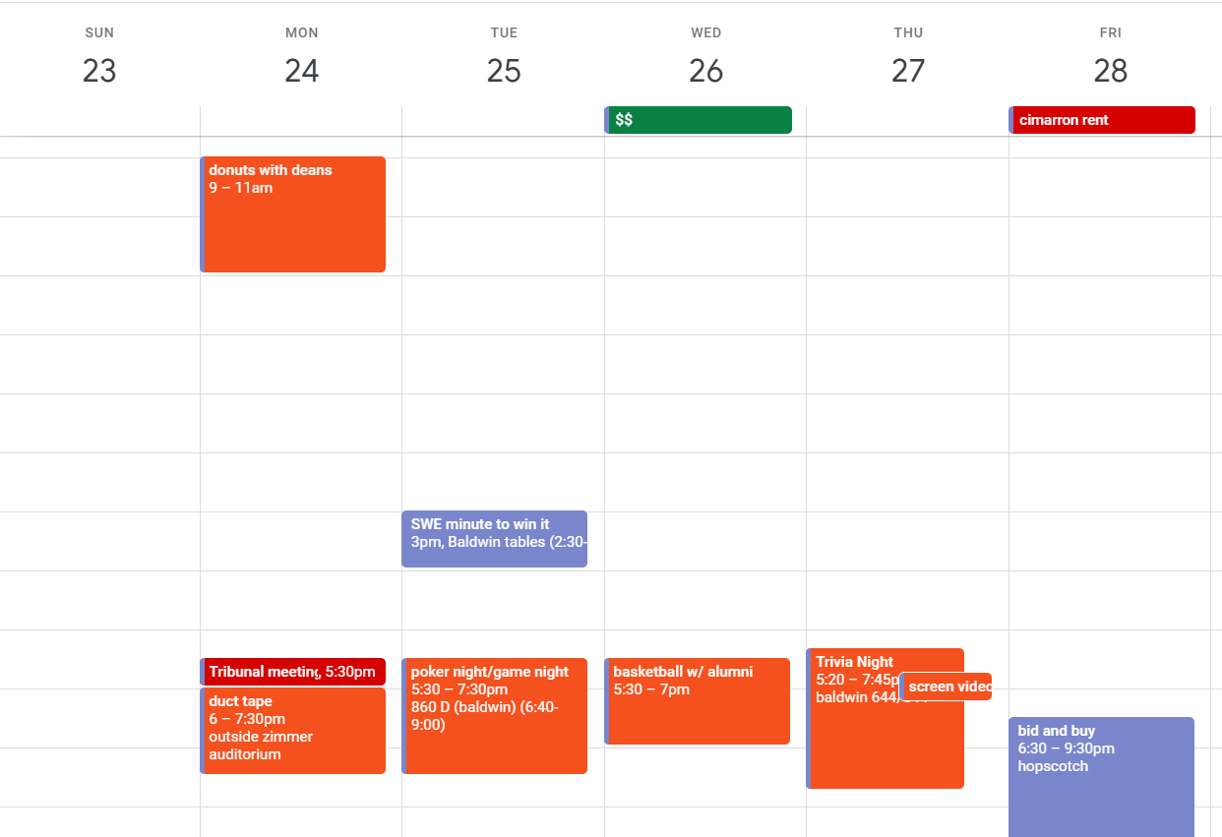
  - Chief of Staff - Gus Kohls
    - Technology (Mihir Patel & Thomas Muha)
      - Having a meeting this week at 6:30pm on Thursday in the Tribunal Office
      - The left computer has been updated to Windows 10. There are issues with it crashing but they will take a look at it in this week's meeting
      - Baldwin TV Submissions is in active development
      - Ordering a mini-PC this week and updating another computer to Windows 10
      - The old Adobe Suite will be updated to Adobe CC this week
    - Innovation (Chirag Agrawal & Jason Choy)
      - TME speaker series - successful pizza delivery and many participants
      - Room booked for Innovation Challenge - Lindner Hall 0040
      - Still need more teams
    - Secretary (Jenna Schniegenberg)
      - Doing great. Meeting minutes are fun and she is uploading them to the drive and website
      - Ordered ink!
    - Communications (Grace Livingston & Kelli Leis)
      - Professional headshot day
      - Cleaned up posting board
    - Internship (Grant Schroeder & Michelle Silverwood)
      - Interns ordered mac shack at their last meeting where they discussed career fair topics!
      - Still doing great work and really helped out at the career (BIG THANKS!!!)
  - Treasurer - Omar Alsayed

  - Senators - Nathan Halbisen & Alex van Haaren
    - Last two weeks in Senate:
      - S.20-A-027 Concerning initial funding for the Survivor SAFE Fund
      - S.20-A-028 Concerning funding for the Spirit of Cincinnati award
      - S.20-A-029 Concerning the appropriation and implementation of the monthly Listen initiative for Spring semester 2020
      - S.20-A-030 Concerning the appropriation and implementation of the Bearcat Friday initiative for Spring semester 2020
      - S.20-E-014 Concerning the approval of the Student Activities Board’s Constitution/Bylaws
      - S.20-A-031 Concerning the block purchase of blue & green exam books for UC students
      - S.20-A-032 Concerning appropriating funds for the Annual Sister in Arms Ceremony
      - S.20-A-033 Concerning funding for Events Promoting the 2020 Student Government Elections
      - S.20-E-014 Concerning the approval of the Student Activities Board’s Constitution/Bylaws
      - S.20-R-011 Concerning the reallocation of funds in FY20 Budget
    - Upcoming Bills
      - S.20-A-035 Concerning co-sponsorship for 81st Annual Sigma Sigma Carnival
      - S.20-A-034 Concerning the purchase of items and volunteers needed for the annual Care About Coy Volunteer Event and Kickball Tournament
      - S.20-E-015 Concerning the correction of a technical errors and word changes within the official Student Government Bylaws
    - EFC News:
      - Please please please be good sports about the elections
  - Pre-Engineering Representatives
    - Clermont (Gabriela Currier)
      - Transition Advising Information Fairs
        - February 26th Clermont 10 am - 3 pm
        - February 19th Blue Ash 10 am - 3 pm
    - Blue Ash (TBD)

- Exec Assignments
  - VP of CA - Nathan Halbisen
    - Academic Affairs (Tala Bras)
      - Keep plan on the co-op advising discussion event. Involve Robbie!
    - Career Development (Alex van Haaren & Ahsan Subzwari)
      - Recap Career Fair!
      - Clean up the office!
      - Discuss any outstanding complaints with the career fair team.
    - Equity & Inclusion (Orè Odubola)
      - Continue to work with orientation on the ceas international student orientation (hopefully they reply)
      - Quiz Bowl!
    - ESOC (Emily Schneider)
      - Send an email out reminding people of the upcoming meeting and include a room number.
    - First Year Experience (Maxwell Muhlbaier)
      - Communicate more with Nathan!
  - VP of Events - Chris Bercz
    - College Wide Events (Ritika Joshi & Andrew Wiedeman)
      - Continue to get sponsorship.
      - Go on tour of Nippert West
      - Update Gant chart regularly.
      - Meet w/ Dr. Bucks to start initial plan.
      - Update their website page on tribunal.uc.edu, work with mihir!
    - Social Events (Maddie Thompson & Mark Bertke)
      - Plan the next social event after egg drop! T-shirt rebranding event?
      - Archery dodgeball?
      - Nerf wars?
      - Movie night?
      - Top Golf?
      - Breakout Room?
      - Reds Game?
    - E-Week (Jash Gada & Gabby Mazzoli)
      - What are your last minute items before EWeek?
      - Send out email to all the teams.
      - Send out email regarding information for the banquet.
      - Buy any accessories needed for the banquet venue.
      - Finalize events and make sure the schedule gets out.
      - Finalize bus captains.
      - Maybe make some slides for the tv displays?
      - Send final events to mihir to put on the calendar.
  - Chief of Staff - Gus Kohls
    - Technology (Mihir Patel & Thomas Muha)
      - Continue to update all computers.
      - Order the mini PC’s.
      - Upgrade to Adobe CC.
      - Finish Baldwin table reservations.
      - Finish online reimbursement form.
    - Innovation (Chirag Agrawal & Jason Choy)
      - Continue to hold weekly meetings.
      - Get any more teams interested and finalize them.
      - Get a final list of judges.
      - Get a list of budgets for each team (itemized lists)
    - Secretary (Jenna Schniegenberg)
      - Keep doing what you’re doing!
    - Communications (Grace Livingston & Kelli Leis)
      - Need dates on a second head shot day.
      - Reach out to other student orgs for your social media collaboration effort
      - Keep bulletins clean during campaigning (which is coming next week). All info needs a tribunal stamp and must follow the rules on the board (top left there is a rule sheet)
    - Internship (Grant Schroeder & Michelle Silverwood)
      - Keep hosting meetings.
      - Follow up with interns to make sure that they have work to do.
      - Get intern feedback about their career fair experience -- what could we do to make it better for the next intern group?
  - Treasurer - Omar Alsayed
    - FINISH ONLINE REIMBURSEMENT FORM
    - Keep doing reimbursements on time!
  - Senators - Nathan Halbisen & Alex van Haaren
    - Keep submitting slides on time! :)
  - Pre-Engineering Representatives
    - Clermont (Gabriela Currier)
      - Information sessions!
    - Blue Ash (TBD)

- Good and Welfare
  - To Grant for bringing his dog
  - For dinner at los potrillos to thank career fair volunteers
  - To career fair being over

