Tribunal Executive Board Meeting
2/03/2020 at 5:00pm EST
405 ERC
----------------------------------------------------------------------------------------------------------------------------
Attendees: Logan Lindsay, Nathan Halbisen, Alex van Haaren, Adit Kulkarni, Ahsan Subzwari, Andrew Muha, Andrew Naughton, Andrew Wiedeman, Chirag Agrawal, Chris Bercz, Emily Schneider, Bailey Freeland, Gabby Mazzoli, Gabriela Currier, Grace Livingston, Grant Schroeder, Greg Muha, Gus Kohls, Izzy Meltzer, Jada Teregeyo, Jash Gada, Jason Choy, Jenna Schniegenberg, Kelli Leis, Leah Hext, Logan Kunz, Maddie Thompson, Mark Bertke, Matt Goodman, Max Muhlbaler, Michelle Silverwood, Mihir Patel, Mitchell Briggs, Nathan Halbisen, Nikkita Sheth, Omar Alsayed, Ore Odubola, Ritika Joshi, Robbie Schad, Scott Tursic, Seth Tursic, Seth Tumlin, Tala Bras, Taylor Morgan, Thomas Muha, Zachary Higgins

----------------------------------------------------------------------------------------------------------------------------

- Officer & Exec Reports
  - President - Logan Lindsay
    - Prepared the office for spring semester! Snacks, snack tab, cleaning, keycards, etc.
    - Exec orientation was a big success, thanks to all for coming!
    - Met with Experience-Based Learning and Career Education (ELCE) before the semester started to chat about upcoming events, career fair, and how we can collaborate the spring semester.
    - Met with Internal Holdover from SG, Joanna Rebitski, to discuss CEAS Tribunal/SG collaboration this semester.
    - CEAS Office 365 Meeting
      - This meeting is to discuss implementation of Office 365 tools into CEAS.
        - This includes things like microsoft teams, microsoft forms, onedrive, etc.
      - I can’t make them cause I’m on co-op, would greatly appreciate someone being my alternate for the semester :-)
    - CEAS Tribunal’s Commemorative Structure to Industry
      - https://docs.google.com/presentation/d/1zGK0WSvNMkdQxyK1LNFmnmpRd0-aTa21LT8_GW3TsN4/edit?usp=sharing
      - Had a meeting with Planning + Design + Construction (PDC) to discuss keywords and brainstorm some structure ideas.
      - The meeting included Student Body President Chandler Rankin, LSA President Jeffrey Bogenshutz, and two DAAP co-ops from PDC.
    - Menstrual Dispenser Expansion
      - Running into a lot of roadblocks!
      - I discovered when meeting with Jim Jordan and Dean Arthur that university facilities restock toiletries in CEAS buildings, not CEAS facilities. This opened up a lot of logistical questions for this initiative. I had reached out to university facilities to start the conversation for CEAS but discovered that Student Body President Chandler Rankin, Vice President Abbie Smith, and a few others from SG have a meeting planned already. Pat Kawolski, Vice President of Finances from UC was also at that meeting and it was to discuss implementation of 10 dispensers that SG owns.
      - Chandler told me he would ask about the feasibility of CEAS installing 13 more. But that conversation did not go very far as Pat is showing some major pushback.
      - They have a follow up meeting in March to discuss implementation and I hope they bring up CEAS again and receive more success.
      - To help show data on this initiative (Pat is a numbers guy), I sent a poll to CEAS-UG-WOMEN to see if they’d like to see this initiative happen.
      - Over ⅕ of the undergraduate women responded, all showing support. Results: https://docs.google.com/forms/d/172h7Fc9bNpI53MqYkhTJDBR4V46jsmyD-VK_YphQpCw/edit#responses
    - National Association of Engineering Student Councils (NAESC) Engineering Summit
      - This is a conference of all the engineering student councils from across the country. The fall semester is the regional one and the spring semester is the national one.
      - Friday/Saturday March 27th/28th at the University of Pittsburgh. We will leave Thursday evening on the 27th, and return on Sunday the 29th.
      - 4.5 hr drive.
      - Interns are welcome to attend!
      - https://forms.gle/TsVraDvZhV28Hf3C8
      - Who wants to go?
      - Trip is paid for by CEAS Tribunal? (not included souvenirs, late night food runs, etc.)
      - Great opportunity for us to go and show off our new swag!
      - The registration deadline is next week so I need to submit that information NOW!
    - NAESC Presidents Meeting
      - They planned it during the Superbowl?? (should be illegal)
    - Sign up for the African American History Month Quiz Bowl (talk to Ore)!
      - Friday before EWeek! Good way to get some extra eweek points!
    - Sign up for Recruitment events!
      - Feb 17th (Next Stop) and Feb 28th (WiE)
      - Talk to Costina Luc if you have any questions!
    - Keep selling E-Week tickets, appreciate you all!
    - minor(/) announcement!
    - Make sure to turn on notifications on slack!
    - Update workstreams/show your progress on there!
    - Schedule weekly meetings with your interns/committee to delegate work and get things done!
  - VP of CA - Nathan Halbisen
    - Academic Affairs (Tala Bras)
      - Goals:
        - Continuing to prepare for RRD and Career Fair.
      - Report:
        - I attended the curriculum committee meeting in place of Tala last Friday.
    - First-Year Experience (Maxwell Muhlbaier)
      - First FYE meeting went well!
    - Equity & Inclusion (Ore Odubola)
      - Transitioning from Moriah Henry, so this semester we’ll be trying to continue that work, implement new ideas.
      - Diversity Training to be coming soon!
    - Career Development (Alex van Haaren & Ahsan Subzwari)
      - Goals:
        - Plan a successful Career Fair.
        - A successful career fair and to help better organize it for the future
        - Re-organize Career Fair planning a bit, train the interns, make sure ELCE knows that we're top dogs
        - Learn how to run the Career Fair.
      - Report:
        - Career Fair planning well is going well (Feb. 11th, 12th)
        - Had a folder weekend
        - Interns are doing great, planning RRD
        - Booklet weekend 1 and 2 coming up
        - Career Fair planning is underway, we have a hundred things to do but me and Alex are taking care of it. Something new that we're doing is creating a re-organized survival guide and a gantt chart to plan Career Fair. It's going well so far and it will be a major help to future chairs!
        - Continuing to prepare for RRD and Career Fair.
    - ESOC (Emily Schneider)
      - Goals:
        - I hope to improve on the newsletter and get more people involved in it.
      - Report:
        - Week 2s newsletter had 15 emails in it almost triple week ones! I’m working on setting up the first ESOC meeting of the semester.
        - First ESOC meeting will be next Thursday at 5:00pm, we will be discussing E-Week.
        - Been working on a list of ideas for the newsletter let me know.
        - Newsletter has received an updated layout, to positive reviews!
  - VP of Events - Chris Bercz
Any exec, interns included, feel free to help plan any of these events if you are interested, just ask the chair and there will be something for you to do. (generally people are very nice in CEAS Tribunal)
    - College Wide Events (Ritika Joshi & Andrew Wiedeman)
      - Meeting at 4:30 pm on Fridays in 650 Baldwin. Started Compiling a list of Potential Industry Sponsors and Judges. Revamping the letter of intent to potential sponsors. Working with Grechen Hart to put together a comprehensive list of CAPSTONE professors. Sending out google forms to potential judges soon. Redesigning logo, will need some exec help (those who are good at digital design).
    - Social Events (Maddie Thompson & Mark Bertke)
      - Perfect Ski Trip, Cyclones game that didn’t pan out, Ect.
        - 104 responses for ski trip, taking 60 this Friday.
    - E-Week (Jash Gada & Gabby Mazzoli)
      - 5 teams signed up! Included is the E-Week event schedule. Looking for orgs to put on some events for E-Week, so if you know or are a part of one who would love to do such a thing reach out to mazzolga@mail.uc.edu. Get your tickets early, they are just starting to be sold this week. E-Week banquet is pretty much planned, Extra bar and long island ‘keg’ are some of the highlights, as well as an expanded. ` - Keep up the great job!!!
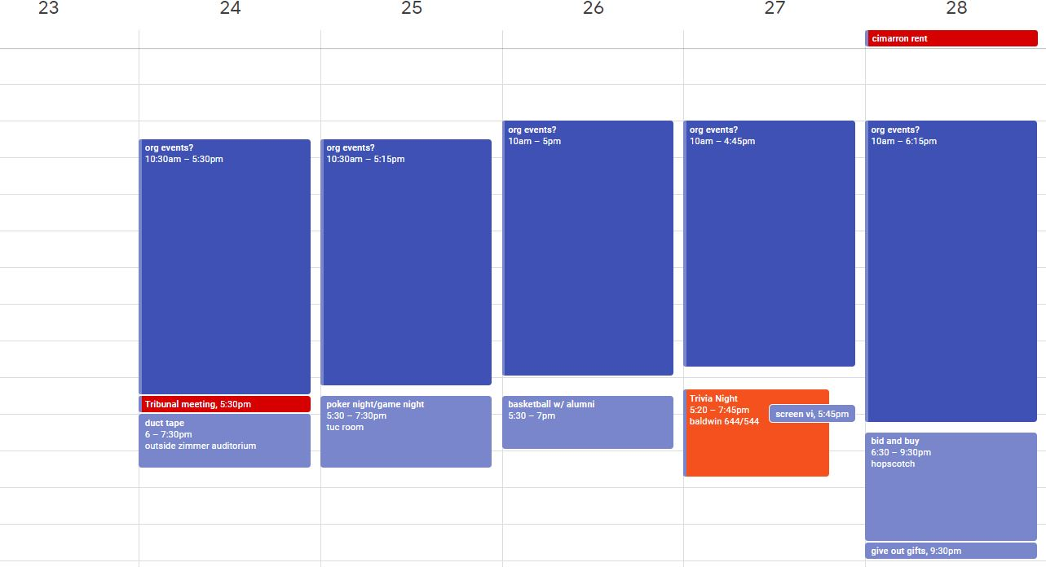
  - Chief of Staff - Gus Kohls
    - Technology (Mihir Patel & Thomas Muha)
      - Request to move $1208.93 from exec expenditure to Technology line item (see email)
    - Innovation (Chirag Agrawal & Jason Choy)
      - Finalized two teams (working on a third currently)
      - Looking to have challenges on the week of April 6th (reserved a space for it??)
      - First speaker is coming next wednesday evening in a collaboration with TME
        - Speaker is CEO of Nichefire (Michael Howard)
        - Topics: his startup journey and best practices to incorporate innovation in startup idea
        - Location: Baldwin 755 2/12/20 6:00 pm
    - Secretary (Jenna Schniegenberg)
      - Doing great. Meeting minutes are fun and she is uploading them to the drive and website
    - Communications (Grace Livingston & Kelli Leis)
      - Keeping the social media going
      - TA/Professor of the Semester is underway
        - Collaborating with E-week on awards
      - Having 2 headshots days this semester (grace is working on setting this up): dates??
      - Ordering swag for tribunal (quarter zips, shirts (need reordered), crew neck sweatshirts, hats??)
      - Collaborating on social media with Alche, AIAA, ASME, SEE, BMES,
      - Working tribunal giveaways (and cleaning closet of past gifts)
    - Internship (Grant Schroeder & Michelle Silverwood)
      - Meeting tonight covering career fair prep (resume review etc) and getting general updates on how they are
      - Interns are working on seperate things and doing great!
      - They are very self sufficient (ordering their own food and creating an E-week team)
  - Treasurer - Omar Alsayed

  - Senators - Nathan Halbisen & Alex van Haaren
    - All of the bills (since the start of Spring Semester)
      - S.20-E-012 Concerning the correction of a number of grammatical and technical errors within the official Student Government bylaws
      - S.20-E-013 Concerning the approval of the College of Arts and Sciences Tribunal’s newly revised governing documents
      - S.20-R-010 Concerning a resolution of support for the implementation of accessibility signage across campus
      - S.20-A-019 Concerning holding the USG Senate meeting at UC Blue Ash on January 29, 2020
      - S.20-A-020 Concerning appropriating funds for a translator for Climate Refugee Week
    - Bills for this Wednesday:
      - S.20-A-027 Concerning initial funding for the Survivor SAFE Fund
      - S.20-A-028 Concerning funding for the Spirit of Cincinnati award
      - S.20-A-029 Concerning the appropriation and implementation of the monthly Listen initiative for Spring Semester 2020
      - S.20-A-030 Concerning the appropriation and implementation of the Bearcat Friday initiative for Spring semester 2020
      - S.20-E-014 Concerning the approval of the Student Activities Board’s Constitution/Bylaws
  - Pre-Engineering Representatives
    - Clermont (Gabriela Currier)
      - Transition Advising Information Fairs
        - February 26th Clermont 10 am - 3 pm
        - February 19th Blue Ash 10 am - 3 pm
    - Blue Ash (TBD)
      - Reached out to Dean of Blue Ash to see if she had anyone in mind.

- Exec Assignments
  - VP of CA - Nathan Halbisen
    - Academic Affairs (Tala Bras)
      - Ensure that there is a student ready to attend each meeting.
      - Plan the co-op advisor feedback event.
      - Do another academic advisors feedback event?
    - First Year Experience (Maxwell Muhlbaier)
      - Special event?
      - Bring in speakers if you’d like
    - Equity & Inclusion (Ore Odubola)
      - CEAS Tribunal Diversity training, get that planned!
      - Collaborate on International Student Orientation
    - Career Development (Alex van Haaren & Ahsan Subzwari)
      - Keep on keepin on.
      - Resume review day good?
      - Exec assignments.
      - Finalize booklets and send them to Evan.
    - ESOC (Emily Schneider)
      - Put the feedback poll into the Student Organization Newsletter for all students.
      - Change the picture at the top, look for a wider photo?
      - Embedded hyperlinks into photos.
      - Work on transition process
  - VP of Events - Chris Bercz
    - College Wide Events (Ritika Joshi & Andrew Wiedeman)
      - Finalize hotcards and print it for career fair.
      - Finish email and Email employers.
      - Follow up with Gretchen Hart to get CAPSTONE professors.
    - Social Events (Maddie Thompson & Mark Bertke)
      - Have fun with ski trip, ensure car pooling is ready.
      - Follow up with Clayton on egg drop.
      - Have interns plan social events for interns or for college.
    - E-Week (Jash Gada & Gabby Mazzoli)
      - Finalize events.
      - Get more teams.
      - Have organizations host events
      - Purchase gifts
      - Order things for events.
      - Order plaques
      - Get committee together for awards
      - Continue to work with BME’s to get stuff for dr. boronyak
  - Chief of Staff - Gus Kohls
    - Technology (Mihir Patel & Thomas Muha)
      - Upgrade everything to Windows 10.
      - Fix server problems (we know they’re coming)
      - Update background picture
      - Finish up any other projects!
    - Innovation (Chirag Agrawal & Jason Choy)
      - Keep having meetings
      - Help the three teams thrive.
      - Schedule a room for the final challenge
      - Reach out to judges
      - Update any documentation
      - Reach out to logan, gus, fg for any help
    - Secretary (Jenna Schniegenberg)
      - Keep doing great on minutes!
      - We might need more ink/paper soon, Logan will let you know!
    - Communications (Grace Livingston & Kelli Leis)
      - Clean up bulletins weekly.
        - We have elections and campaigning soon ALL STUFF REGARDING THIS MUST HAVE A TRIBUNAL STAMP
    - Internship (Grant Schroeder & Michelle Silverwood)
      - Follow up with interns, ensure they’re happy
      - Follow up with exec and make sure interns are doing work
  - Treasurer - Omar Alsayed
    - FINISH ONLINE REIMBURSEMENT FORM
    - Keep doing reimbursements!
  - Senators - Nathan Halbisen & Alex van Haaren
    - BE ON TIME WITH REPORTS TO LOGAN
  - Pre-Engineering Representatives
    - Clermont (Gabriela Currier)
      - Information sessions!
    - Blue Ash (TBD)
      - Will follow up with dean!

- Good and Welfare
  - To Emily for getting engaged!!
  - To Travis Kelce for winning the superbowl as a UC alumni!
  - To Nathan Halbisen for turning 21!
  - To beating Houston on Saturday!!
  - To career fair for somewhat doing their jobs

- Sigma Sigma
  - Voted to donate $500 to event

